January 8, 2026
The Honorable Troy Meink
Secretary, United States Air Force
1670 Air Force
Pentagon, Washington, DC 20330
Dear Secretary Meink,

We write to you today to express our concern regarding continued delays in C-130J aircraft deliveries to the Montana Air National Guard and to emphasize the importance of timely receipt. The Montana Air National Guard 120th Airlift Wing currently operates a fleet of 8 C-130Hs, all of which are scheduled to be replaced with the upgraded and improved C-130J model. That critical upgrade will allow the Wing to better respond to national defense operations, natural disasters, conduct more efficient airlift operations, and carry out their wildfire and rescue missions.
The FY 2022 and FY 2023 Defense Appropriations bills provided funding for 32 C-130Js for the Air National Guard. The National Guard Bureau subsequently approved Montana’s 120th Airlift Wing as a priority location, clearing the way for Montana to take delivery of the planes and utilize them on a shorter timeline.
The 120th Airlift Wing was originally slated to receive their first C-130Js in April 2026 but has since been notified that delivery will be delayed until at least July 2026, with an indication that further delays are possible. These delays negatively impact readiness, operational security, and the Airlift Wing’s modernization program, wasting time and resources maintaining the existing C-130H fleet. The statutorily required transition to the C-130J aircraft cannot be further delayed. We request that you provide answers to the following questions:
- What, specifically, has caused these delivery delays?
- What remedies can be pursued to bring this program back on schedule?
Thank you for your support and we look forward to working with you to ensure Montana’s Air National Guard receives the aircraft they have been promised on a reasonable timeline.
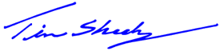
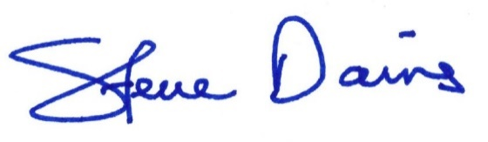
Sincerely,

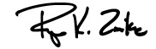
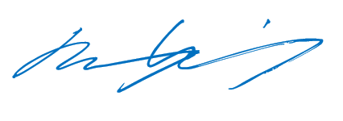
_________________________ _________________________
Steve Daines Tim Sheehy
United States Senator United States Senator
_________________________ _________________________
Troy Downing Ryan Zinke
United States Congressman United States Congressman
CC: Lt. Gen Linda Hurry (AF Materiel Command)
Gen. Steven Nordhaus, Chief, NGB

