TESTIMONY OF JIM KALITOWSKI, CHAIRMAN

MUSSELSHELL – JUDITH RURAL WATER SYSTEM

BEFORE THE

U.S. SENATE COMMITTEE ON ENERGY AND NATURAL RESOURCES

ON S 1552

A BILL TO AUTHORIZE THE

DRY REDWATER REGIONAL WATER AUTHORITY SYSTEM AND

THE MUSSELSHELL – JUDITH RURAL WATER SYSTEM

IN THE STATE OF MONTANA

Room 366 of the Dirksen Senate Office Building

Thursday, June 18, 2015

2:00 pm

Chairman Murkowski, Ranking Member Cantwell and members of the Senate Committee on Energy and Natural Resources, my name is Jim Kalitowski, and I serve as the Chairman of the Central Montana Regional Water Authority (CMRWA) which has been working on the Musselshell-Judith Rural Water System project in Montana. I also serve as a councilman for the City of Harlowton, Montana.

On behalf of the CMRWA and the City of Harlowton, I wish to thank Chairman Murkowski, Ranking Member Cantwell and the members of the Senate Subcommittee on Water and Power for the opportunity to testify on Senate Bill 1552, Authorization of the Dry-Redwater Water Authority System and the Musselshell-Judith Rural Water System in the State of Montana. The legislation authorizes the Secretary of the Interior to use designated funding to pay for the construction of these rural water projects.

The CMRWA Board and member communities wish to thank Senator Steve Daines and his dedicated staff who have helped us craft this important legislation and introduce it on behalf of the CMRWA. We also wish to thank Senator Jon Tester and his staff who have provided valuable guidance to our organization over the past eight years during the planning of this project.

The passage of S. 1552 will provide the legal mechanism for federal funding of the Musselshell-Judith Rural Water System. S. 1552 is consistent with the Rural Water Supply Act of 2006 that authorized the Secretary of the Interior to establish and implement a Rural Water Supply Program. The Rural Water Supply Act requires the completion of a comprehensive planning process including an Appraisal Report and Feasibility Report. The Musselshell-Judith project received approval for its Appraisal Report in 2010 and recently received Reclamation approval for its Feasibility Report in January 2015. **This is significant because we understand that our project is the first to complete the entire planning process prescribed under the Rural Water Supply Act of 2006.**

**Project Need**

The Central Montana Regional Water Authority (CMRWA) is a coalition of eight incorporated communities, several unincorporated communities and many rural families areas within six counties in central Montana.

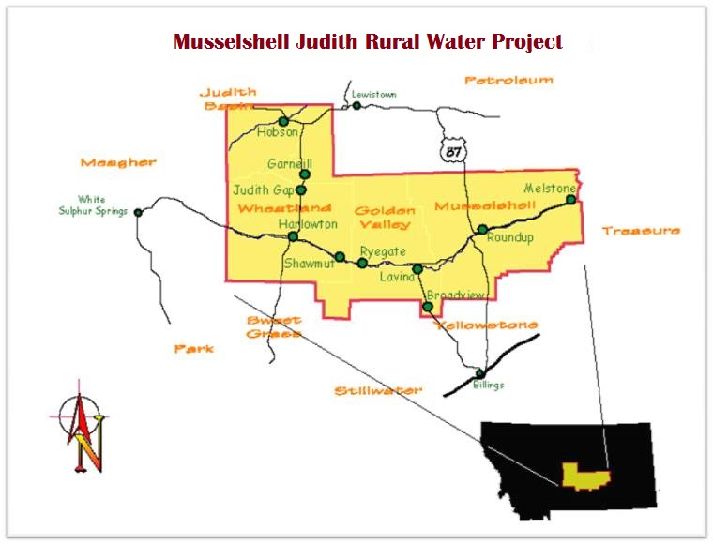

Examples of drinking water challenges currently faced by members of the Authority include the following:

* The City of Roundup obtains its water from a coal mine and the water is so mineralized that it is nearly undrinkable. Iron content is nearly five times the Safe Drinking Water Act standard. Almost all residents buy bottled water and/or use costly in-home reverse osmosis units (over 95% of residents in Roundu purchase bottled water). The multi community survey indicated that 69% of residents within the regional water system area purchase bottled water. In addition, residents are forced to operate water softeners because the water is so corrosive to appliances. Recent flood damage included losing the water main beneath the river connecting the wells to the infiltration gallery requiring costly emergency repairs to the system. With the wells and infiltration gallery being within the flood plain, this is an issue that the City will continue to deal with in the future.

**Roundup Water**

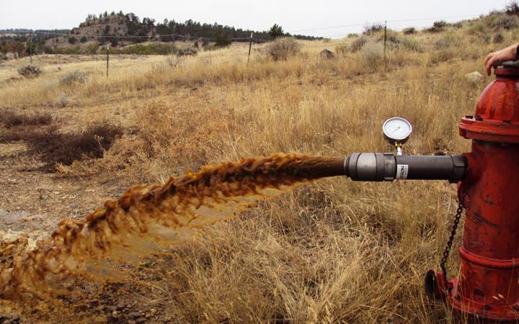

* The Town of Melstone has nearly run out of water several times in the last decade as flows in the Musselshell River approached zero. They have recently decided to decommission their surface water treatment plant and rely solely on their groundwater wells. They constructed two new wells in 2011 with moderate capacities; however both are contaminated with iron bacteria which will require ongoing treatment.
* The Town of Broadview has historically operated two deep, low production, and poor quality wells. If either well were to go out of service, the Town would not be able to meet the average day flow needs of the community which is a significant public health and safety threat to the residents. The two newest wells are also deep (over 1,000 feet) and low production (15 and 20 gpm) and were completed in 2014. While this has added additional capacity to the system, it is not sufficient. The water is extremely mineralized and corrosive so most residents drink bottled water.
* The Town of Harlowton has wells with high sulfate content that make the water very difficult to drink without treatment. Additionally, in recent years one of the town’s main production wells (Pritchard Well) began delivering a high volume of black particulate forcing the Town to shut it down and only use it when needed to meet maximum day demands. The Town also had to take one well (South Well) offline during the 2011 flood because of surface water flooding at the well site. Finally, the only other well the city owns (Thompson Well) is threatened by an underground storage tank leak which has resulted in detectable levels of benzene in the well.
* The Town of Hobson has transient non-community public water systems and residents utilizing groundwater from a shallow aquifer with high levels of nitrates. Frequently, these concentrations have exceeded the enforceable standards.
* The Town of Lavina has a history of autonomous non-community public and private water systems which have been identified as containing high levels of nitrates.

**Health Effects of Existing Water Quality**

A summary of some of the existing water quality issues and the corresponding impacts on health faced by members of the CMRWA include:

**Nitrates.** High levels of nitrates in drinking water present a significant threat to public health and safety, especially to infants under 6 months of age. Infants that ingest drinking water with nitrates above the EPA’s primary maximum contaminant level could contract a serious illness and, if untreated, may die. Known symptoms include shortness of breath and blue baby syndrome.

**Iron.** Although iron represents a vital mineral in every healthy individual’s diet, the level of iron ingested should be controlled. Indeed, a sustained long term heavy dose can be detrimental to one’s health. People with a condition known as Hemochromatosis are the most susceptible to potential harmful effects caused by the long term exposure to high concentrations of iron in drinking water. Early symptoms of the disease include hair loss, impotence, abdominal pain and shortness of breath. Symptoms become increasingly severe as the disease progresses, causing diabetes, heart failure and even death. It was estimated in a CDC publication from 2002 that approximately 1 in every 250 to 300 people suffer from the symptoms of Hemochromatosis. There are no known cures for Hemochromatosis and once the liver or heart has been damaged due to the progression of the disease, treatment can stop additional damage but cannot reverse it.

**Sulfate.** High concentrations of sulfate in drinking water contribute to a poor aesthetic quality and can also produce a laxative effect for those who ingest it. Some individuals can, however, overcome this condition after becoming acclimated to the water. Most of the communities within the region have documented levels of sulfate of at least twice the recommended limit.

**Sodium.** Most of the water supplies in the planning area have very high concentrations of sodium. Acute effects of excessive salt intake include nausea, convulsions, muscular twitching and rigidity, cerebral and pulmonary edema and can aggravate people suffering with chronic congestive heart failure

**Reliability of Water Supplies**

In general, the reliability of the existing water supplies of member communities is questionable. Several of the communities have experienced water shortages or are very susceptible to that situation due to the precarious condition of their supply infrastructure. Lack of access to a reliable water supply obviously represents a significant public health and safety risk to the residents of this region.

**Financial Need**

Reclamation prepared a Socioeconomic Study on the planning area as part of the final Feasibility Report. The study shows that the area has a very low Median Household Income (MHI). The MHIs of member communities ranged from $21,838 to $43,750 per year. This is significantly below both Montana’s and the federal MHI which points to a very strong need for federal financial assistance on this project.

**Project History**

The CMRWA was formed in 2004 to address the significant drinking water issues in the region. The CMRWA has been planning the Musselshell Judith Rural Water System for eleven years with the goal to provide communities and rural residents in the region with a reliable supply of high quality drinking water from the Madison Aquifer groundwater.

The project will utilize a 250 mile piping system to deliver water to users. Once water is pumped out of the proposed wells the entire system will be fed by gravity except one area (Broadview) which requires a small booster pumping station. The system design is simple yet very efficient for energy use and operations since no treatment plant is required. The groundwater meets all Primary and Secondary Federal drinking water standards. The water will require no treatment except chlorination.

The CMRWA completed its first test well in 2005 which demonstrated that an adequate quantity of high quality water could be developed from the Madison Aquifer for the CMRWA members. The CMRWA initiated work on the Appraisal Report in 2007 and obtained approval for the Appraisal Report from Reclamation in 2010. Evaluation of water supply alternatives completed during the first phase of the Feasibility Report recommended that the wellfield be developed northwest of Judith Gap, Montana called Ubet. The CMRWA completed a test well at this site in 2012 with State, Federal and local funds. The test well demonstrated that an adequate quantity and quality of water was available at this site.

**Based on the Ubet test well information, the CMRWA filed for and received the full water rights for the project in 2014 from the State of Montana.**  The test well information also allowed for the completion of the first draft of Feasibility Report which was submitted to Reclamation in July 2013. **After working through a vigorous and multi-level review process by Reclamation, the CMRWA was able to obtain final approval for the Feasibility Report in January 2015.**

Reclamation determined that the water project meets the requirements outlined in Reclamation’s Directives and Standards, meets the requirements outlined in the Economic and Environmental Principles and Guidelines for Water and Related Resources Implementation Studies (Principles and Guidelines), meets the National Environmental Policy Act, Endangered Species Act, and National Historic Preservation Act, and the project has a benefit cost ratio of 1.28:1 which meet the Principles and Guidelines requirements for wise federal investment under the National Economic Development (NED) assessment.

**Conclusion**

In conclusion, Chairman Murkowski, Ranking Member Cantwell and committee members, it is obvious that the residents, institutions and businesses of this region face significant deficiencies with the existing water supplies. These deficiencies impact the health and safety of residents across this region of Montana. The deficiencies with the water supplies also have a significant economic impact on these communities which have Median Household Incomes among the lowest in Montana. The CMRWA has already spent nearly $2 million dollars of State, local and Federal funding on the project to date for test well construction, engineering, planning and administration of the project. We sincerely hope this proves to be a wise investment with the continuation and ultimate completion of this project.

We strongly support S. 1552 as the next step in our communities’ efforts to obtain a safe and reliable drinking water supply for the generations to come. We request that you support our efforts by moving this legislation forward. We also support Senate Bill 1365 which will provide needed construction dollars for rural water projects. Once our system is authorized, we will need these funds to provide construction funding to match State and local funding sources.

Chairman Murkowski, Ranking Member Cantwell and committee members, I thank you for allowing me to testify on behalf of the CMRWA and the City of Harlowton for this critical legislation for our region. An adequate quantity of safe drinking water is a basic human need that most Americans take for granted. Please support our efforts to secure a system that will deliver that same promise to our citizens.

For more information please visit CMRWA’s website at <http://www.centralmontanawater.com/> or contact the project engineer, Bob Church, at [rchurch@greatwesteng.com](mailto:rchurch@greatwesteng.com) or the project administrator Monty Sealey at pmservices@midrivers.com.

IN00577_

**Central Montana Regional Water Authority**

**P.O. Box 175**

**Roundup, MT 59072**