PO Box 7186 Missoula, MT 59807 (406) 543-0054

2 June 2016

Senator Steve Daines
U.S. Senate
320 Hart Senate Office Building
Washington, D.C., 20510

Dear Steve:

I understand that Montana staff for the Trust for Public Lands has reached out to you to sponsor legislation that would name an unnamed peak in the Madison Range for Alex Diekmann, the long-time TPL project manager who lost a courageous battle earlier this year to cancer. I wanted to let you know that my organization and I strongly endorse this request.

The results of Alex’s work to help preserve special places can be found all across Montana. His creative collaboration with policy makers, landowners and conservation groups led to protection, with public support, as well as when necessary, congressional backing, of important landscapes from Northwest Montana to the Madison River region and other special niches in the southwest reaches of our state. It is fitting that the unnamed peak proposed as a memorial to Alex’s legacy sits above the Sun Ranch in the Madison River watershed. It looks out on some of the very lands he helped protect.

If there is one thing that often distinguishes Montanans from other folks in this nation it is that we recognize the value in honoring good work. We would do well to honor Alex by naming a special mountain for a special conservationist.

Sincerely,

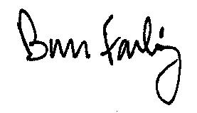
Bruce Farling
Executive Director

